Sheerhatch Pupil premium strategy statement 2021-2022

This statement details our school’s use of pupil premium (and recovery premium for the 2021 to 2022 academic year) funding to help improve the attainment of our disadvantaged pupils.

It outlines our pupil premium strategy, how we intend to spend the funding in this academic year and the effect that last year’s spending of pupil premium had within our school.

School overview
Detail | Data
School name | Sheerhatch Primary School
Number of pupils in school | 126
Proportion (%) of pupil premium eligible pupils | 14.3%
Academic year/years that our current pupil premium strategy plan covers (3 year plans are recommended) | 2021-22
Date this statement was published | 30th Sept 2021
Date on which it will be reviewed | 30th Sept 2022
Statement authorised by | Helen Ryan
Pupil premium lead | Danica Kipling
Governor / Trustee lead | Mary Whitehead
Funding overview
Detail | Amount
Pupil premium funding allocation this academic year | £22,641
Recovery premium funding allocation this academic year | £2,610
Pupil premium funding carried forward from previous years (enter £0 if not applicable) | £0
Total budget for this academic year  If your school is an academy in a trust that pools this funding, state the amount available to your school this academic year | £25,251

Part A: Pupil premium strategy plan

Statement of intent
- Every child has an equal chance to succeed and not disadvantaged
- Every child to achieve
- Every child is given a range of positive and wider opportunities

Challenges
This details the key challenges to achievement that we have identified among our disadvantaged pupils.
Challenge number | Detail of challenge
1 | Lower engagement in lockdown has created some gaps in learning
2 | Attendance weak for some families
3 | Maths identified as a challenge for these pupils (Data and Pupil voice)
4 | Reduced engagement has affected pupils wellbeing and attitudes to learning
5

Intended outcomes
This explains the outcomes we are aiming for by the end of our current strategy plan, and how we will measure whether they have been achieved.
Intended outcome | Success criteria
Identified gaps are closed | Target Tracker data shows improved data
Improved attendance | PP children attendance is not lower than non PP children
Improved progress in maths for Pupil Premium | Average: 6 steps progress for Pupil Premium children
Improved wellbeing for all | Individual Wellbeing surveys
Increased range of opportunities available for PP children | ’30 Things at Sheerhatch’ booklet ticked off

Activity in this academic year
This details how we intend to spend our pupil premium (and recovery premium funding) this academic year to address the challenges listed above.

Teaching (for example, CPD, recruitment and retention)
Budgeted cost: £ 837
Activity | Evidence that supports this approach | Challenge number(s) addressed
Traded services provided by Borough | Supports teachers with closing the gaps in learning | All
Buy-back Ed Psych package | Quality First Teaching supports learning | All
CPD Diamond (range of courses available) | Specific CPD related to specific needs | All

Targeted academic support (for example, tutoring, one-to-one support structured interventions)
Budgeted cost: £ 17,297.50
Activity | Evidence that supports this approach | Challenge number(s) addressed
Small group intervention | See Teaching Toolkit doc below (EEF) | X9
1:1 tutoring/intervention (such as Literacy Fischer Trust) | See Teaching Toolkit doc below (EEF) | X1

Wider strategies (for example, related to attendance, behaviour, wellbeing)
Budgeted cost: £ 6810
Activity | Evidence that supports this approach | Challenge number(s) addressed
Regular Liaison with families with poor attendance | Attendance data often improves after close communication with families | X2
Welfare meetings with the Family Support Worker | Children wellbeing surveys mention the effectiveness of the Family support worker directly | X10
Enrichment Opportunities | Parent and children’s surveys highlight these activities | x18
Family support with other costs | Parent surveys show that this support is welcomed | x18

Total budgeted cost: £ 24,944.50

Part B: Review of outcomes in the previous academic year

Pupil premium strategy outcomes
This details the impact that our pupil premium activity had on pupils in the 2020 to 2021 academic year.
Attendance of PP pupils:97.32% in 2020-21 (up from 96.09 in 2019-20) – NB figures affected by partial closure and covid absence codes
Parent Survey comments: 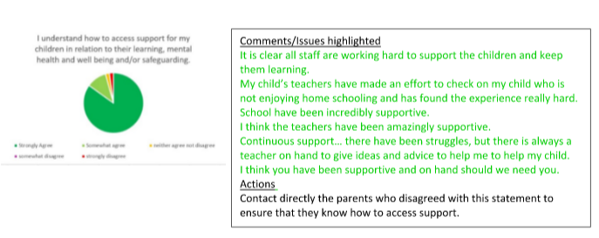
PP progress compared to non PP: Average progress across Reading, Writing and Maths within the academic year 2020-21 was 4.5 points (Target Tracker) as opposed to 4.6 points for non PP

Externally provided programmes
Please include the names of any non-DfE programmes that you purchased in the previous academic year. This will help the Department for Education identify which ones are popular in England
Programme | Provider
PIXL | John Rowling

Service pupil premium funding (optional)
For schools that receive this funding, you may wish to provide the following information:
Measure | Details
How did you spend your service pupil premium allocation last academic year? | n/a
What was the impact of that spending on service pupil premium eligible pupils?

Further information (optional)
The grant is also used to support the vulnerable families:
-Care club costs covered
-School uniform (if necessary)
-Extra curricular clubs costs are covered
-Residential trips cost is supported

Teaching and Learning Toolkit
Which intervention and why?

https://educationendowmentfoundation.org.uk/education-evidence/teaching-learning-toolkit

