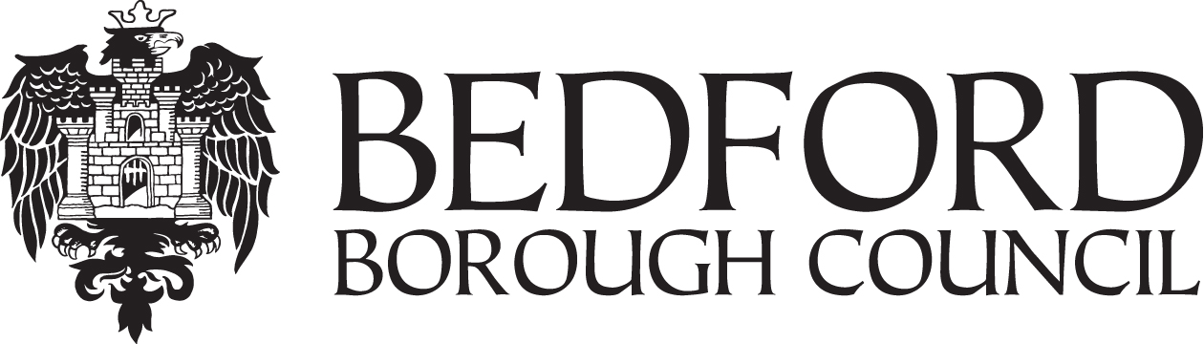

Information Sheet
Starting School 2021

This leaflet for parents/carers of children starting school (Year R) for the first time in September 2021 explains how to apply for a lower/primary school place for a child born between 1 September 2016 and 31 August 2017.

All the information you need to apply for a school place is available on our website www.bedford.gov.uk/startingschool It gives details of all the schools in the area and a PDF copy of the admissions booklet, Starting School 2021, which explains how we process your application for a school place. Please read this carefully before you apply.

The website also allows residents of Bedford Borough Council to apply for a place online at www.bedford.gov.uk/onlineadmissions

You may apply using a paper application form if you prefer. An application form can be requested from your local Bedford Borough lower/primary school or by contacting the School Admissions Service: email: admissions@bedford.gov.uk tel: 01234 718120

If you live in another Local Authority you must complete your home Local Authority’s application form and return it to them. Contact information is overleaf.

Application deadline 15 January 2021

Starting School Admissions Timetable

September 2020
We will publish information about the Starting School process.

26 September 2020 – 15 January 2021
You can apply online or you can complete and return a paper application form to the School Admissions Service.

15 January 2021
Last day for applications.

16 April 2021
If you have applied online you will receive an email to let you know the outcome of your application. If you have not applied online we will post a letter to you on this day.

Contact Us
School Admissions Service General Enquiries - 01234 718120
Email: admissions@bedford.gov.uk

Contact details for school admission teams in neighbouring authorities
Cambridgeshire  Tel: 0345 045 1370  admissions@cambridgeshire.gov.uk | Central Bedfordshire  Tel: 0300 300 8037  admissions@centralbedfordshire.gov.uk
Milton Keynes  Tel: (01908) 253338  primaryadmissions@milton-keynes.gov.uk | Northamptonshire  Tel: 0300 126 1000  admissions@childrenfirstnorthamptonshire.co.uk

