New Rabbits Memories of our Summer Holiday
Make a collection of memories over the summer of your seven week school holiday. Please get a shoe box or plastic sandwich box, something to collect your treasures of the summer holidays in. Each week, choose something from the list that you can place into your memory box. We will share these in the first week back in September
Please feel free to be as creative as you like with this or just keep it basic depending on your time and child’s enthusiasm for each object/ activity that is to go into the box.
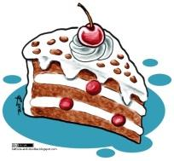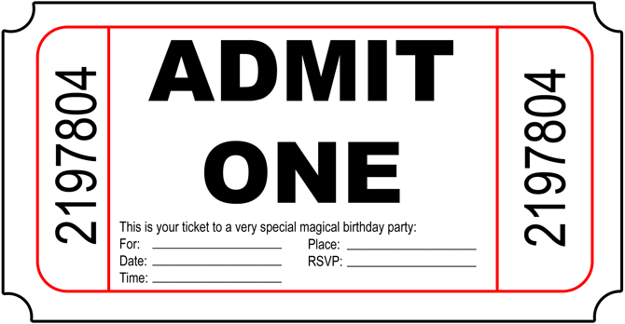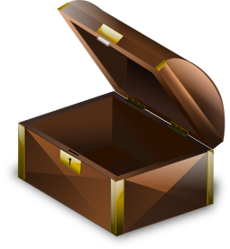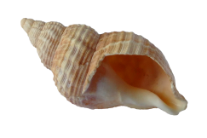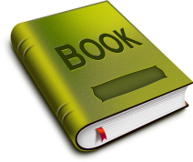
Week | Find, task or activity. | Tick
1 | Photo – A photo of something thing you enjoyed this holiday. (or a few things)  This could be made into a collage of photos that you have made into a picture. Be creative.
2 | Ticket – A ticket or leaflet of something you did or somewhere you went. (Bus ride, entrance ticket etc.)  You could draw picture of the place if you went to and that will tell us more about your trip.
3 | Object – Collect an object from your holidays; pebble, shell, flower that you press. Or a small toy/ souvenir you have been lucky enough to get that has special memories for you  Maybe this is something that you made during the holidays, out of recycled materials.
4 | Food – A wrapper, menu, picture.  Something you have eaten or made, like a cake, biscuits or sandwich.  Maybe you could take photos of the food you made.
5 | Book – A small book or photo of your favourite book you have read this holiday.  Can you write a sentence about why you like the book?
6 | My friends – Picture or photo of the friends you have seen, social distancing or on Zoom  What makes your friends special?
7 | My Family – Photos or paintings of your family, parents, siblings, grandparents, aunties and uncles, cousins etc.  You could make a collage of photos or paint a picture and label who people are.
In September our topic is a ‘Basketful of Memories’
We will be using this box as memories of their holidays to support our first week’s learning.

