The Magical Globe - Story starter!
“Hmmm. Where shall we go this time?” Jeremy asked his brother.
“How about there!?” replied Max excitedly. “We’ve always talked about going there!”
The brothers both put their fingers on the part of the world they had chosen, and waited for the magic to happen.
“I wonder if it will be as fun as our last trip,” mused Jeremy, as the globe began to glow…
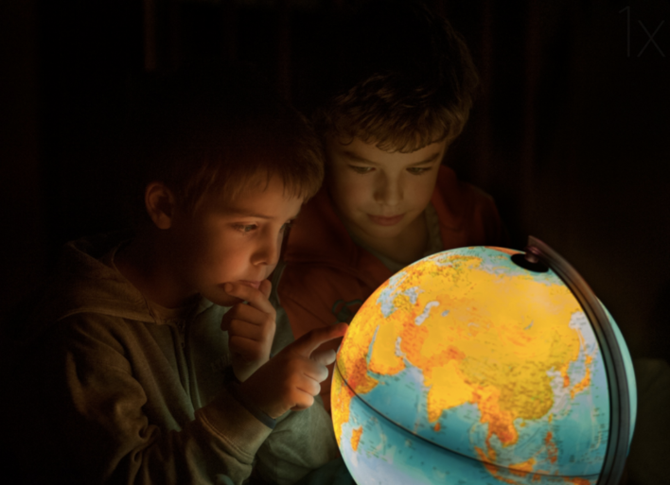
Sick Sentences

The boys talked. The light was off in their room. They put their fingers on the globe. Something happened.

