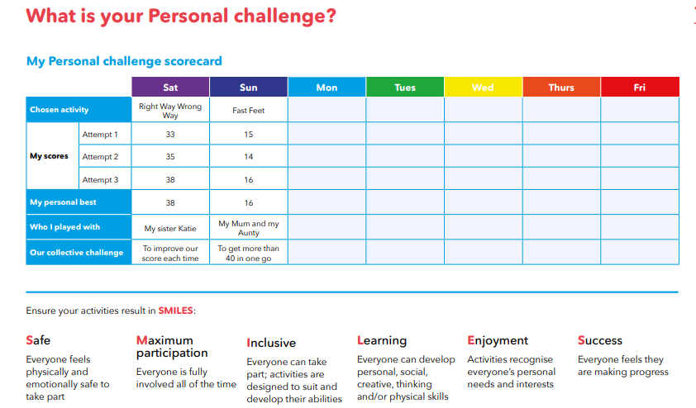

Name ______________

Year group ________ House ___________

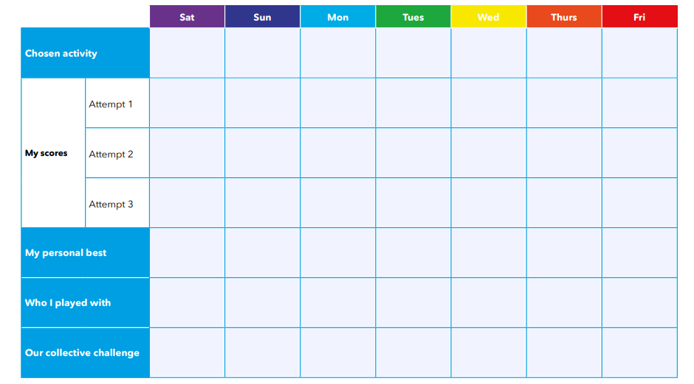

**Horizontal climbing**

**Swipe and swap**

**Race across the river**

**Sock wars**

**Cool catcher**

**In the box**

**Speed**

**bounce**