Story | Character / Setting | Climax or problem | Ending
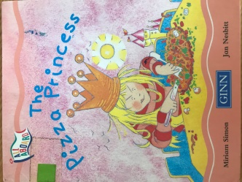 | Princess  Castle | Very rude and greedy for pizza.  Her maid and cook left her because she was so rude | She got very hungry  And then said please and thank you for pizza  Everyone was happy
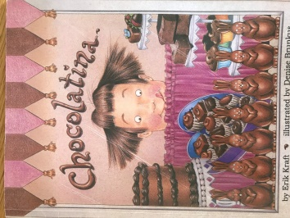 | Tina. (Chocolatine)  School | Loved Chocolate  Greedy for chocolate  Wish she was what she ate.  Became chocolate | Realized being chocolate wasn’t so good, as people wanted to eat her and she couldn’t move. Whish she was normal again
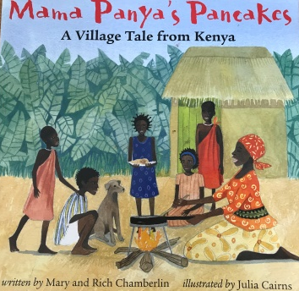 | Adika  Kenya / Africa | Poor family walking to market to buy ingredients s for pancakes but Adika invite so many people to eat pancakes with them | All the friends come to eat pancake and bring more food so there is enough food and they all share
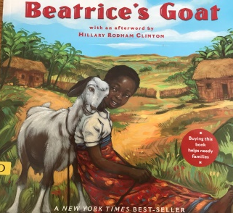 | Beatrice  Uganda ?Africa | Poor family. No money to send Beatrice to school but they get a gift a goat. Beatrice care for and milk goats. Sells milk to get money | Has enough money to pay for school.  Her friend then gets as a gift of a goat so will be able to sell milk too.
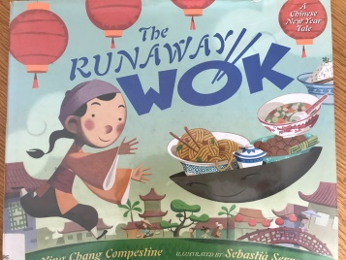 | Ming  (Magic Wok)  Village in China | Poor family, no food for new year party.  Magic wok goes to rich family and collects food, toys and money | The family have a big party and share everything they have with the village.  Wok take rich selfish family away and never seen agian
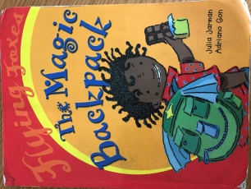 | Josh  (Magic backpack)  UK and Ghana /Africa | Josh forgets to take chocolate and cocoa to school for cake!  Magic back pack take him to Uncle Williams cocoa plantation to collect it | Josh flies back  just in time to make the delicious Super-Duper round the world chocolate cake
Story | Character / Setting | Climax or problem | Ending
