Maths
For the next two weeks you need to load up the White Rose Maths website using this address:
https://whiterosemaths.com/homelearning/year-2/
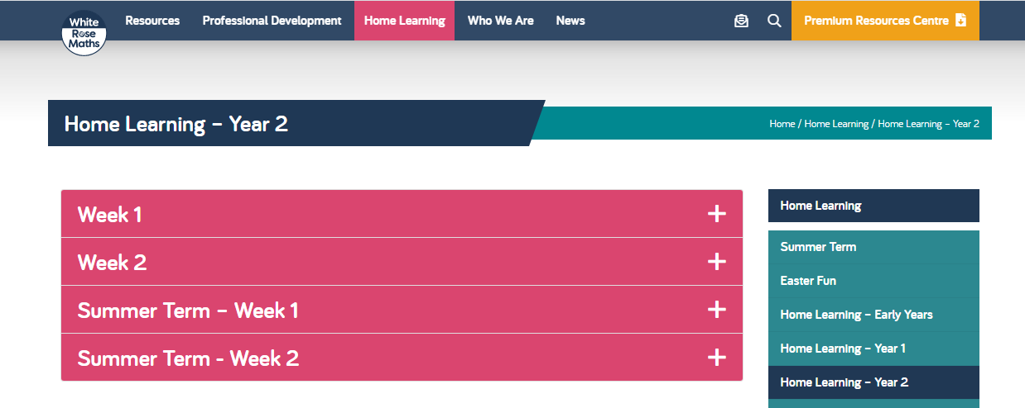
Once you navigate to the year 2 – Home learning section you will see there are options as seen below. You need to click on the Summer term – Weeks 3&4.

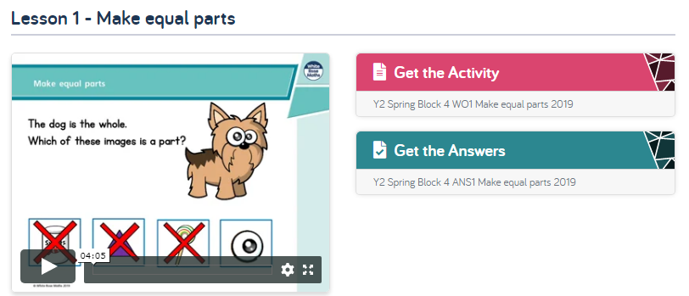
You can work through each week completing the activities.

1. You need to watch the video explaining the task.
2. Next, click on get the activity. Either print off the activity or complete the answers in your home school work book.
3. Finally, open up the get the answers and check through your work. A good idea would be to get an adult to go through the answers with you.

Additional work
Please still use the TT rock stars website to practise your times tables. It great to see lots of you using it and moving up levels! I have attached some paper copies if you would like to print them out to practise.
Also, you can use the Numbots website for additional maths fluency practise. Your password and login details are the same as TT rock stars. If you need your login details again please email using the address below and I will send you your login details.
If you feel you would like extra maths work, again please email me and will happily send some to you!
a.crouch@sheerhatchprimary.org.uk

