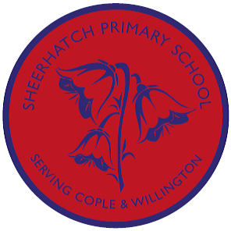

In **Music**, we will be learning the songs for the year 5 and 6 production.

This will be the musical “Olivia!” written by Malcolm Sircom.

In Science, we are covering a unit called ‘Body Health’. This unit focuses on:

Describing the impact of diet and exercise on human health.

Evaluating healthy eating guidance.

Identifying criteria to judge whether a drink or snack is healthy.

Using secondary sources to investigate how scientific ideas were developed in the past.

Investigating variables that affect pulse rate.

Identifying the impact exercise has on the way the body functions.

In **History**, we’ll be studying:

Aspects of French history whilst on our residential visit to France.

**Topic Overview:**

***Vive La France***

**Owls**

**Summer Term 2019**

In Geography, we’ll be:

Using six-figure grid references, symbols and keys on maps.

Locating the world’s countries, using maps.

Focusing on Europe to ...

Learn about its environmental regions.

Know its key physical and human characteristics.

Locate its major cities.

In Computing, we’ll be:

Understanding that being safe when we visit websites is similar to staying safe in real life.

Recognising websites that are alright for us to visit and when to ask an adult for advice.

Exploring what information is appropriate to be put online.

Write programs using nested loops.

Using Java Script coding.

In **Art and DT,** we’ll:

Art

Combining our drawing and painting skills to create backdrops for the year 5 and 6 production “Olivia!”.

DT – Resistant Materials

Improving our woodworking skills.

Designing and creating a wooden toy that uses cams.

In RE, we’ll be thinking about:

*How far does faith enable resilience?*

*(Focusing on Christians, Muslims, Hindus, Jews and comparing them to non-religious people)*