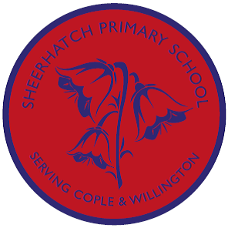
In Music, we shall be learning some exciting songs from the movies. We are learning them to prepare for a concert in the summer, more to follow.

In Science, we will be learning about nutrition in animals including humans.
This will include:
- the food pyramid
- the Eatwell plate
- analysing our own food diaries
- investigating everyday foods
- the diets of different animals

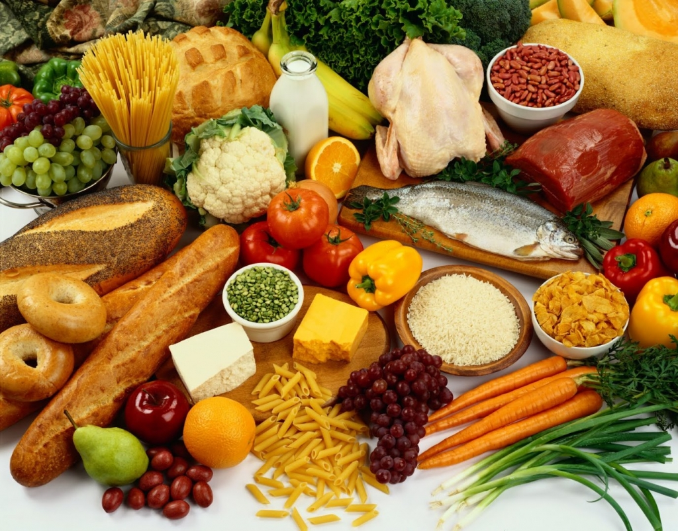

In Geography, we’ll be
travelling around the world with a focus on Europe, India and North America in line with our novel, “Around the world in 80 days”

There will be a big focus on mapwork.

We will identify continents, countries and cities and investigate land use and physical features in our key countries.

Topic Overview:
Let’s go!
Badgers and Foxes
Spring Term A 2018


In RE, we shall be thinking about the kind of world that Jesus wanted.

In Computing, we are carrying on with our coding unit of work and how to staff safe online.
In Spanish we are learning our numbers between 11-20, the days of the week and the months, and hopefully some colours and shapes.

In English, we’ll be:
- following the adventures of Phileas Fogg in ‘Around the World in EightyDays’ by Jules Verne and writing stories inspired by this
- investigating non-fiction information texts and writing our own about our favourite animals

In Art and DT, we shall be looking at the work of Giuseppe Arcimboldo and cooking different foods from around the world.

In Art, we’ll:

- Design and create a collage of either a hot or cold country.
- Explore the works of Spanish painters Pablo Picasso and Joan Miro. We will compare their work and will use their work to portray Spain.
- Create sand sculptures.

