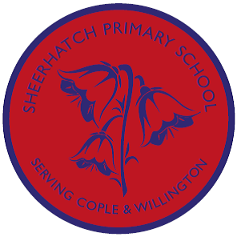
In Music, we will be learning to play the glockenspiel. By the end of term we aim
to compose our own pieces of music using this
instrument.

In Science, we will be continuing to learn about states of matter. This will include:
- solids, liquids and gases
- heating and cooling
- permanent and reversible changes (this will be continued in Year Five)
- the different elements of the water cycle

In History and Geography, we’ll be studying:
- Scott and Amundsen’s expeditions to the South Pole.
- Modern day visitors to Antarctica.
- The terrain of Antarctica.
- The ownership of Antarctica.
- The environmental impact that human activity has on Antarctica both from a local and international point of view.
- The wildlife of Antarctica.

Topic Overview:
Antarctic Adventures
Badgers
Autumn B
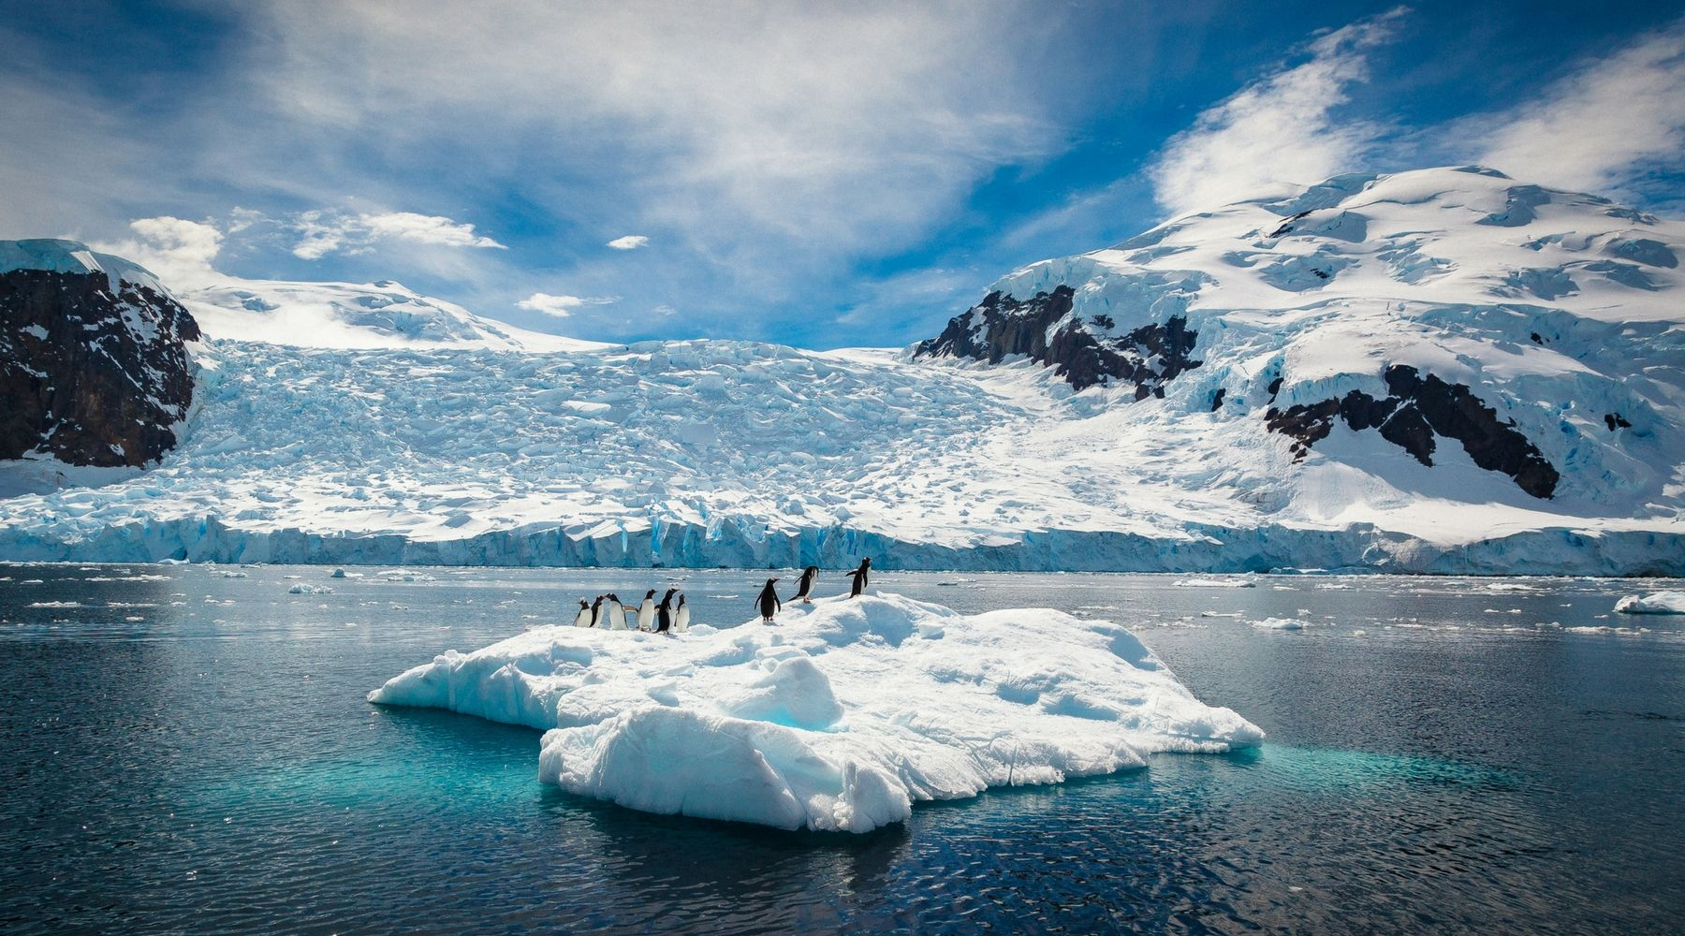

In RE, Our topic for this term is ‘What do the religions teach about the natural world and why should we care about it?’

In Art and DT:
- We will work in small groups to design and build a sledge for transporting essential scientific equipment across the icy terrain. We will judge the sledges on safety and ease of movement.
- In a link with the wildlife side of our topic we will be creating stencils to and making Antarctic animal screen
prints.

In Computing, we will be continuing to develop our coding knowledge by creating programs with loops, events and conditionals and writing algorithms for everyday tasks.
By the end we hope to have created interactive games and stories based on our topic to share.

In English, we’ll be:
- Writing a perilous ice adventure story.
- Creating an informative non-fiction page about Antarctic wildlife.
- We will also be developing our speaking and listening skills by taking part in several debates over the course of the topic.

