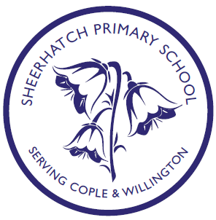

Attainment Outcomes 2017

 | Nationally | Bedford Borough | Cople Lower School | Willington Lower School
Early Years Foundation Stage (% achieving Good Level of Development | 70.7% | 67% | 70% | 67%
Year 1 (% passing phonics check) | 81% | 77% | 67% | 69%
Key Stage 1 (%achieving expected level) | Maths 74%  Reading 76% Writing 68% | Maths 71%  Reading 73% Writing 66% | Maths 80%  Reading 80% Writing 73.3% | Maths 60%  Reading 70% Writing 50%
Key Stage 1 (%achieving greater depth) | Maths 21%  Reading 25%  Writing 16% | Maths 16%  Reading 22% Writing 13% | Maths 13.3%  Reading 13.3% Writing 13.3% | Maths 0%  Reading 0% Writing 0%

