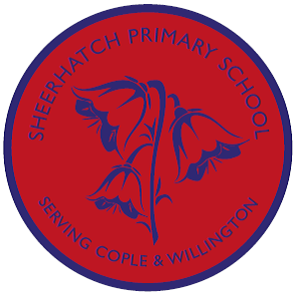
In Music, We will be looking at music old and new from France, India and The USA. We will be listening and composing our own pieces.

In Science, we will be learning about nutrition in animals including humans.
This will include:
- the food pyramid
- the Eatwell plate
- analysing our own food diaries
- investigating everyday foods
- the diets of different animals

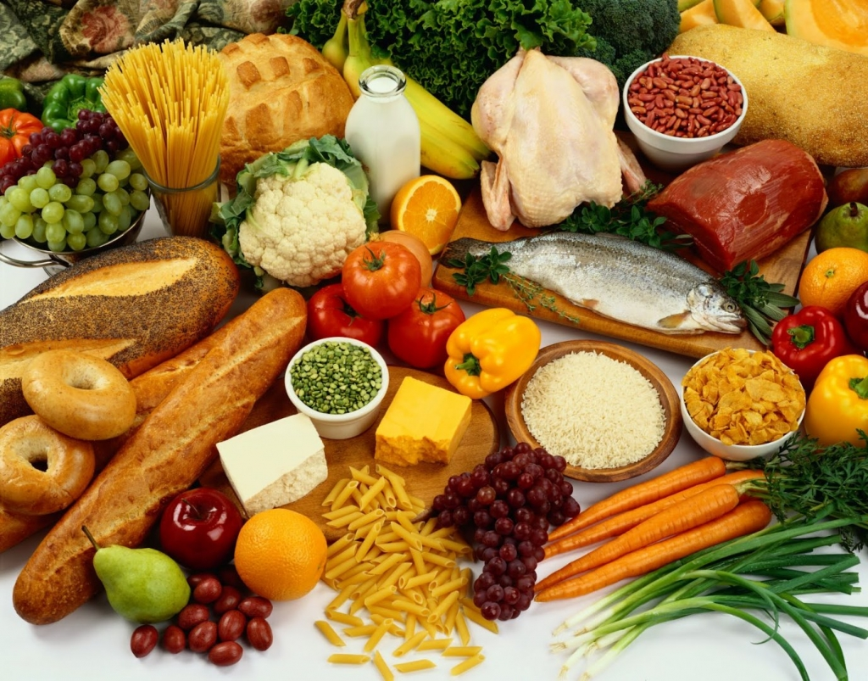

In Geography, we’ll be studying:

Travels around the world with a focus on Europe, India and North America in line with our novel, “Around the world in 80 days”

There will be a big focus on map work.

We will identify continents, countries and cities and investigate land use and physical features in our key countries.

Topic Overview:
Let’s go!
Badgers and Foxes
Spring Term A 2018


In RE, Our topic for this term is “Understanding Christianity”.
- We will look at the theme of” Life as a Journey”in line with our literacy focus
- We will look at baptism/birth and marriage in both Christianity and Hinduism

In Computing, We will be using the computers to research our topic. We will also be developing our skills in Word.
In French
- We’ll be studying The Hungry Caterpillar in French
- We will learn colours, numbers, foods and holiday terms
- We will practise speaking and writing in French

In English, we’ll be:
- following the adventures of Phileas Fogg in ‘Around the World in EightyDays’ by Jules Verne and writing stories inspired by this
- investigating non-fiction information texts and writing our own about our favourite animals

In Art and DT,
- We will begin by cooking food from France, India and The USA.
- In the second half of the topic we will investigate the art of Giuseppe Arcimboldo and produce our own works inspired by his.

In Art, we’ll:

- Design and create a collage of either a hot or cold country.
- Explore the works of Spanish painters Pablo Picasso and Joan Miro. We will compare their work and will use their work to portray Spain.
- Create sand sculptures.

